**Date:14/12/2021**

**Faculty of Engineering**



**Innovation Project Proposal**

1. **Title of Project: Smart Home Automation**
2. **Faculty Mentor: Dr Anil S Hiwale**

**Gaurav G Narkhede**

1. **Details of Group:**

| **Sr. No.** | **Name of Student** | **Year - School** | **Email Address** | **Mobile** |
| --- | --- | --- | --- | --- |
| **1** | **Shainesh Nikam** | **3rd** | **yash.nikam2000@gmail.com** | **8308516101** |
| **2** | **Shweta Sawant** | **3rd** | **shweta.sawant6565@gmail.com** | **9373243606** |
| **3** | **Ruchin Shroff** | **3rd** | **ruchin.shroff@gmail.com** | **8793514266** |
| **4** | **Keshav Rathi** | **3rd** | **Keshavrathi9426@gmail.com** | **9328644329** |
| **5** | **Sejal Ratnaparkhi** | **3rd** | **sejalratnaparkhi20@gmail.com** | **8390854825** |

1. **References Journal / Conference papers related to work :**

**a. K. Agarwal, A. Agarwal and G. Misra, "Review and Performance Analysis on Wireless Smart Home and Home Automation using IoT," *2019 Third International conference on I-SMAC (IoT in Social, Mobile, Analytics and Cloud) (I-SMAC)*, 2019, pp. 629-633, doi: 10.1109/I-SMAC47947.2019.9032629.**

**b.T. Chaurasia and P. K. Jain, "Enhanced Smart Home Automation System based on Internet of Things," *2019 Third International conference on I-SMAC (IoT in Social, Mobile, Analytics and Cloud) (I-SMAC)*, 2019, pp. 709-713, doi: 10.1109/I-SMAC47947.2019.9032685.**

**c. Kazuyuki Yamamoto and Nobuhisa Ayugase "A HOME TERMINAL SYSTEM USING THE HOME AREA NETWORK" IEEE Trans. on CE vol. CE-30 1984.**

**d.Yoshiji Minagawa Kazuho Uemura Masahiro Inoue Mitsunobu Esaki and Manabu Fujii "A HOME INFORMATION-NETWORK SYSTEM" Mitsubishi Denki Giho vol. 58 no. 9 1984.**

1. **Project Details and Objectives: (Attach details as supporting doc’s)**

**a. Cost effective architecture.**

**b. Customizable modules.**

**c. Home automation with security.**

**d. Covers all features of automation.**

1. **Methodology: (Attach details as supporting doc’s)**

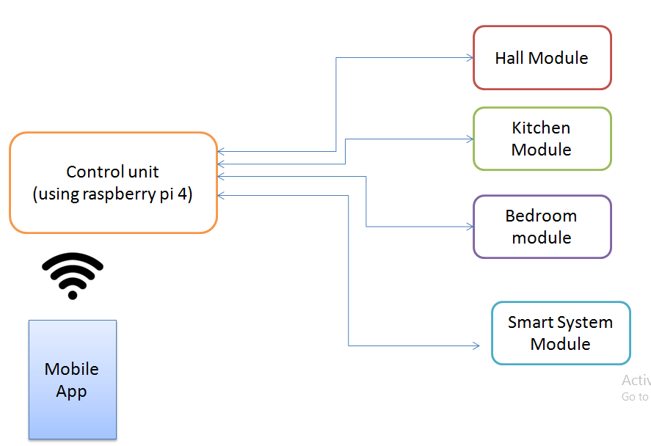

**a. We use mobile AI application for controlling the system**

**b. Control unit is a main hardware which control all modules**

**c. Modules are the separate hardware with Node MCU and sensors**

**d. We use wifi and internet technology for communication**

1. **Resources Required:**

**a. Smart controller (raspberry pi 4 and Node MCU)**

**b. Sensors and Relays**

**c. Cloud hosting for mobile Application and website**

**d. PCB and Casing**

1. **Detailed Project Description:**

**With the development of new electronic technologies and their integration with older, traditional building technologies, smart home is at last becoming a real possibility. At first "home computer" was an experimental system in 1966, then in the early 1980’s the smart home automation was initiated as a project of the National Research Center of the National Association of Home Builders (NAHB) with the cooperation of a collection of major industrial partners (1). Even though smart home is not a new term for science society but it’s still far more away from people’s vision and audition. Because recently various work is done with the design and general overview of the possible remote access approaches for controlling devices, or in cases of simulating the smart home itself. The design and implementation of an off-the-shelf Smart Home remote control application has been limited to simply the computer applications and just in cases mobile and web applications development. The "smart home" technology is one realization of home automation ideals using a specific set of technologies. It's a home that has highly advanced automatic systems for lighting, temperature control, security system, With AI development technology.**

**The smart home that learns your habits is not just a home automation system. It comes with a user's habit learning function. The outcome is a smart home that controls itself features such as light, climate or multimedia, without any (necessary) user input or interaction, according to their habits. Moreover, It allows the communication of all smart electronic devices in your home and their control at home or at a distance using a mobile device. it is more than just a smart home automation solution. It is the "virtual butler" of your house.**

1. **Bill of Material with Budgetary Cost: (Attach details as supporting doc’s)**

| Components & Equipments | | |  | Quantity |  | Costing |
| --- | --- | --- | --- | --- | --- | --- |
| Raspbarry pi 4 | |  |  | 2 |  | 35,000 |
| Controller Casing with fan | | |  | 2 |  | 10,493 |
| mega Wifi R3 Atmega 2560 | | |  | 5 |  | 13,426 |
| 16 channel relay board | | |  | 10 |  | 7,630 |
| Biometric Sensor | |  |  | 2 |  | 1000 |
| Ethernet security camera | | |  | 5 |  | 1,690 |
| DTH 11 Digital temperature sensor | | | | 10 |  | 1,428 |
| MQ2 Gas sensor | |  |  | 10 |  | 1,372 |
| Sound Detector | |  |  | 10 |  | 896 |
| LDR light module | |  |  | 10 |  | 560 |
| Slider motor | |  |  | 5 |  | 8,940 |
| 13.3 inch LCD Screen | | |  | 1 |  | 45,666 |
| cloud hosting | |  |  | 1 |  | 3,000 |
| water pumps | |  |  | 1 |  | 31,500 |
| CNC outsourcing | |  |  | 1 |  | 10,000 |
| interior design lights | | |  | 10 |  | 38,500 |
|  |  |  |  | Total |  | 2,64,101 |